Adam Wells
PET3361 – Nutrition and Metabolism in Sport and Exercise Science – Spring 2019
University of Central Florida
Diet Reflection Assignment

Due Dates
- Food Log 1 (10 points) – Week 3: January 21-27, 2019
- Food Log 2 (10 points) – Week 13: April 1-7, 2019
- Video Reflection (25 points) – Week 14: April 14, 2019
- Upload evidence for commenting on video reflection of two peers (5 points) – Week 15: April 21, 2019

Purpose
- To integrate the scientific literature discussed during key lectures (carbs, fats and proteins, weight management, nutrient timing) in to your own diet for the purposes of practicing the implementation of nutritional strategies based on your nutritional/training goals.

Skills
Students, athletes, and active individuals alike are becoming increasingly exposed to nutrition misinformation. In order to recognize fact from fiction and promote science-based nutrition information to the public, aspiring nutrition professionals must develop an in depth understanding of the role of various nutrients in improving health, sports performance and recovery. The challenge however, is to apply this nutritional knowledge and develop a strategy that optimizes nutrition for particular fitness goal in a real-world scenario. In today's complex world, simply knowing how to use tools and knowledge in a single domain is not sufficient to remain competitive as individuals. Students must also learn to apply tools and knowledge in new domains and different situations.
As part of this assignment, you will practice the following skills that are essential to providing yourself with a nutrition plan. In this assignment you will:
- Track your daily macronutrient intake using the Myfitnesspal® app during week 3 of the semester
  - Use the built in bar-code scanner and/or the food record database to accurately record food types and portion sizes.
  - Synthesize two dietary food logs (beginning and end of semester) that encompass all food and drink consumed for each of the two weeks.
- Compose a well-organized, clear and concise reflection of the changes you made/plan to make to your diet based on the information presented during class lectures OR justify making no changes.
- Film and post a video reflection (5-minute max. length)
  - Reflections will be in video format. You may film your video and upload the file, or film directly through the discussion post. Instructions on how to do this can be found here [links to LMS]. You will film your reflection and upload to Webcourses.
  - You will experience how it feels to candidly discuss your nutritional strategy and any challenges you faced while implementing what you perceive to be an optimal diet.
  - Reflection should be a well-organized, clear and concise reflection of the changes you made/plan to make to your diet between based on the information presented during class lectures.

Knowledge
This assignment will also help you become familiar with the following important content knowledge in the discipline.
- How to manipulate carbohydrate, fat and protein intake to enhance metabolism, performance and recovery
- How to manipulate carbohydrate, fat and protein intake to optimize health, growth and weight management
- How to manipulate carbohydrate, fat and protein intake around patterns of substrate depletion and repletion during various exercise intensities
- How to appropriately time nutritional strategies to maximize anabolic potential

To Do List
To complete this assignment, you will need to do the following:
- Watch the Myfitnesspal tutorial videos posted on Webcourses.
- Login to Myfitnesspal or create a free Myfitnesspal account.
- Enter your personal information into the Myfitnesspal app (height, weight, gender, current activity level) and select a dietary goal.
- Record the timing and quantity of everything you eat and drink during week 3 of the semester using the Myfitnesspal® app (following completion of the bioenergetics module). Your food log should include the following: Your dietary goal, 7-day food log, and macronutrient charts (see tutorials). Your upload should be in Microsoft Word or pdf. format.
- Between weeks 4 and 12, begin to develop a nutritional strategy and make planned adjustments to your diet. This nutritional strategy should be based upon the information presented on the following lectures (Carbohydrates, Fats, Protein, Nutrient Timing, and Weight Management), and should be consistent with your dietary goal.
- Record the timing and quantity of everything you eat and drink during week 13 of the semester using the Myfitnesspal app. Your food log should include the following: Your dietary goal, 7-day food log, and macronutrient charts (see tutorials). Your upload should be in Microsoft Word or pdf. format. You should implement any changes based off of what you have learned during the course.
- Film and post a video reflection (no more than 5-minutes) detailing the changes you made to your diet over the course of the semester. Detail any challenges you faced when modifying your diet for the week. Your reflection should include the following:
  - Discussion on dietary goal.
  - Discussion on previous dietary practice, and why this practice may/may not be optimal for attaining your goal. This should include relevant information from the following lectures: Carbohydrates, Fats, Proteins, Nutrient Timing and Weight Management).
  - Discussion on proposed changes in dietary habits AND proposed benefits OR justify the need for no change of changes AND justification for why current practice is optimal. This should be based on lecture content.
- Comment on two video reflections posted by your peers
  - Screenshot your comments and upload them in Webcourses. Comments to your peers should be thoughtful, constructive and objective.

Criteria for success: Please see the attached rubrics.
- Food Logs (10 points
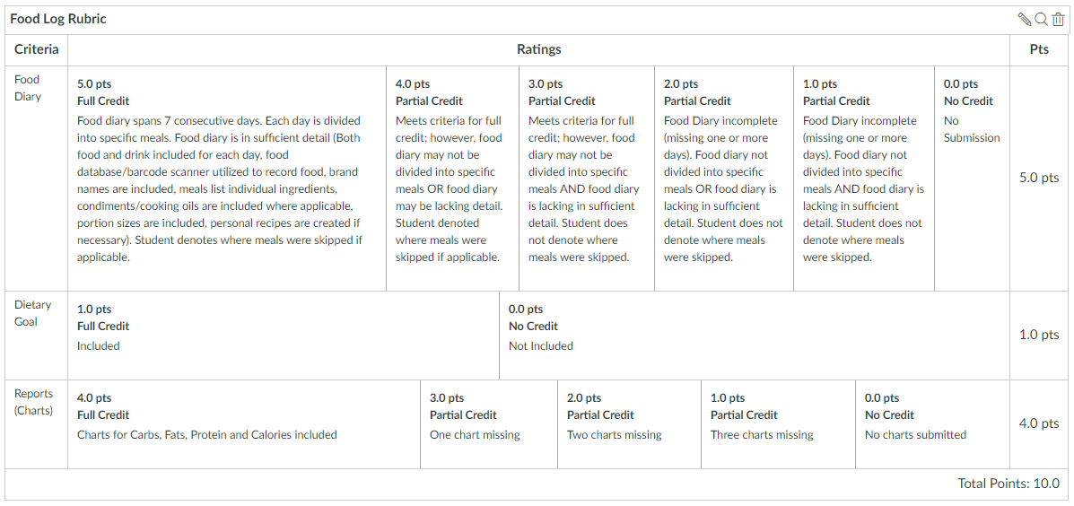

- Video Reflection (25 points)
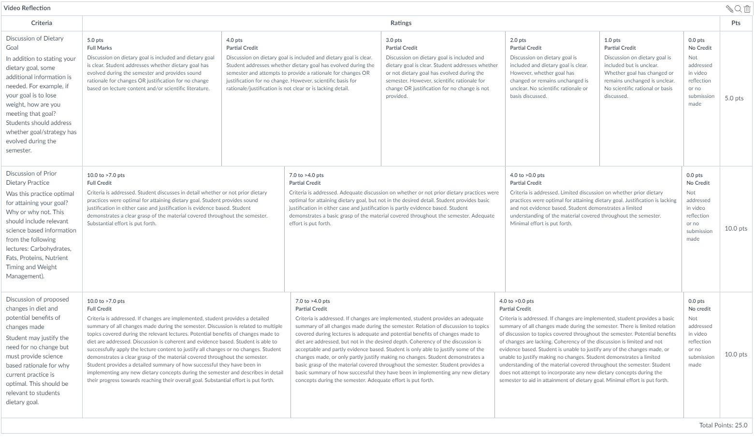

- Comment on the reflections of two (2) peers (5 points).
